Name: govind vuppu ______________________ GR006539_____________________________

1. In Windows, install the Simple Network Management Protocol (SNMP) by clicking on the checkbox next to it. If it is already checked, then leave it checked. Also make sure that WMI SNMP Provider is also checked. A reboot may be necessary.

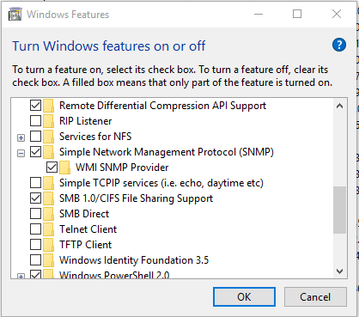

1. In Windows, go to Control Panel- Administrative Tools – and double-click on Services.
2. Scroll to the SNMP Service and make sure that it is running. Double-click on it.
3. Click on the Agent Tab and put in your name in the *Contact* field and “school” in for the location. Under the Service area make sure all checkboxes are checked then click *Apply*.

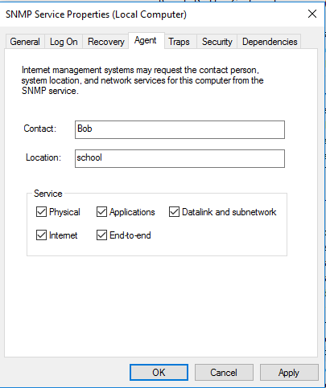

1. Click on the Traps tab. In the *Community name* type in *public* and click *Add to list*. Under *Trap destinations* click on *Add*. Put in the instructors IP address (instructor will provide) and click *Add*. Click OK to save and close the settings.
2. Your instructor will run an SNMP trap receiver (iReasoning MIB Browser for example) and display it on the projector.
3. Go to Control Panel – Network and Sharing Center and click on Change adapter settings. If you have an Ethernet network adapter, take it out of service by right-clicking on it and selecting disable. Once it is disabled, then double-click it to re-enable it.
4. The traps from your computer should be sent to your instructor’s computer and displayed on the projector in the trap receiver window.

What was displayed as the description for the trap that was sent? ____linkDown___________________________

End of Procedure